Crimes at Forester’s Academy

By
Jack Jeffrey

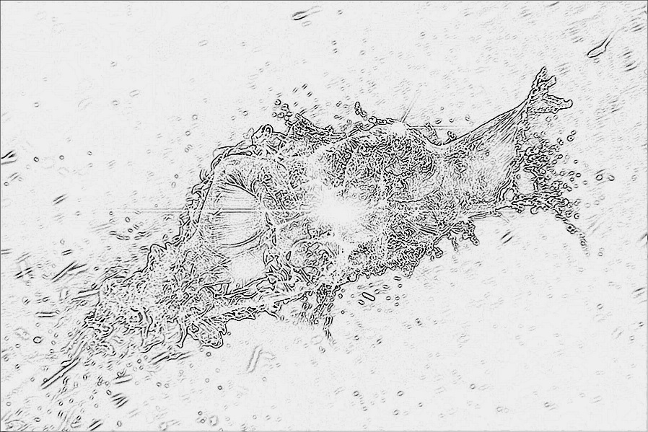

Crimes at Forester’s Academy

Table of Contents

Chapter 1- 1
Chapter 2- 3
Chapter 3- 7
Chapter 4- 9
Chapter 5- 17
Chapter 6- 20
Chapter 7- 24
Chapter 8- 29
Chapter 9- 35
Chapter 10- 42

Chapter 1

I woke up with a splitting headache. I walked down the hallway and stumbled down the stairs to my parent's bedroom. I unlocked it with the gold pocket knife my Uncle Sean got me for my seventh birthday.
He was the only one that cared about me and now, he was dead. About a month ago his house burned down and he got trapped and burned to a crisp. After that, my parents had no one to take care of me. Now they looked for every little thing to be able to send me to Forester's Academy. Anyway, I snuck in and went to the medicine cabinet and out tumbled a pair of keys to my dad GTR. I wasn't legally allowed to drive being only 13, but I could drive better than any professional driver and I loved the feeling of it. The feeling was amazing the speed and the sense that no one can stop you. I snatched the keys and sprinted down to our foreign car garage and started the engine and flew off the property in a flash of black. I found an open road and took off. 120, 130,150, 180 and then finally the sad funeral music played they demons had come to ruin my fun, the bloodcurdling sound of a siren. The cop pulled me over and immediately recognized my unique face from the countless other arrests. His name was Officer Bronson. He was practically a friend after he how many times he had arrested me and talked to me to try and set me straight by talking to me.
"Hey Cord, you know I have to take back to the station, I thought you said you learned your lesson." He drove slowly back to the station and when we got there he handcuffed me and called my parents to come pick me up. They came bursting in with a nasty scowl on their faces, my penny-pinching father was furious because he had to pay a major $1000 fine for a billionaire. He didn't care for me just his company and his money, and my mother just did what he said. She never had her own opinion and did anything he said. We drove home and the only sound that was heard was dad's angry grumbling.

Chapter 2

I sat down in the living room while preparing for a lecture and waiting for my parents' argument to end. They whispered about how I was a little disobedient delinquent. Finally after what felt like hours of just sitting and suspense, my parents came out. "Cord, this is the third time this year you have gotten arrested for underage driving and speeding," My mother said. “We have no choice but to send you to Forester's academy." “But haven’t you seen the news, something crazy is going on there, first the principal goes missing, then those three kids!" I quickly shouted. “The police have already investigated what happened, it was just a couple of runaways." I ran to my room and slammed the door as loud as possible. I woke up the next morning to a moving van in my driveway, a suitcase and a note from my father saying "Put your stuff in the boxes you're moving to Forester's today." I did as the note said after I finished I tossed my stuff in the van. My mom called me to the car. I ran inside to my and snatched the knife. Then I ran back outside and took one last look at my house and then got in the car. When we arrived there was a wide, fat and creepy looking man ready to greet us with a smile. "Hello you must be Cord, welcome to Foresters Academy, your guide will be first-year Kate Gonzalez and third year Kyle Kuzma." "Hi, I'm Kate, let me show you around campus." It was amazing there was everything from libraries to lounges. Finally, we arrived at my room. When I opened the door to my dorm I felt like one of those people on HGTV getting their house revealed. It had everything I was passionate about. The couch cushions were seats from a Lamborghini. The TV was h1uge, and my favorite thing about it was the wallpaper. One was a blazing angry fire, one was the Arctic, one was a huge raging thunderstorm, and one was the peaceful colorful ocean.

