**Crimes at Forester’s Academy**

**By Jack Jeffrey**

“Standing there waiting for the fire that I had accidentally created I saw a boy who stood with a horrified look on his face pointing towards me. I spun around to see a metal rod with a blade spinning towards me. I braced myself for sudden death but nothing happened. I opened my eyes to see a wall of ice with the rod trapped in its icy barrier.”

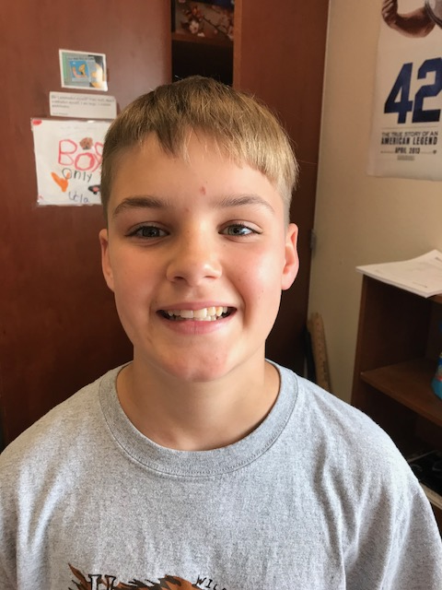

**Author Bio:**

Jack Jeffrey is an 11 year old kid who lives in Texas. He loves basketball and even has his own website dedicated to NBA topics called *The Basketball Know It All*. He wrote this novel for national novel writing month or NaNoWriMo. Jack wrote the novel in a course of one month. It is fantastic!