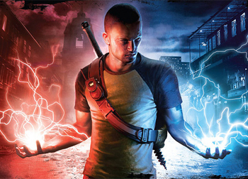

**Jack Jeffrey**

**Crimes at Forester’s Academy**